By: Sahbaj Singh

Module B.4

Tic Tac Toe

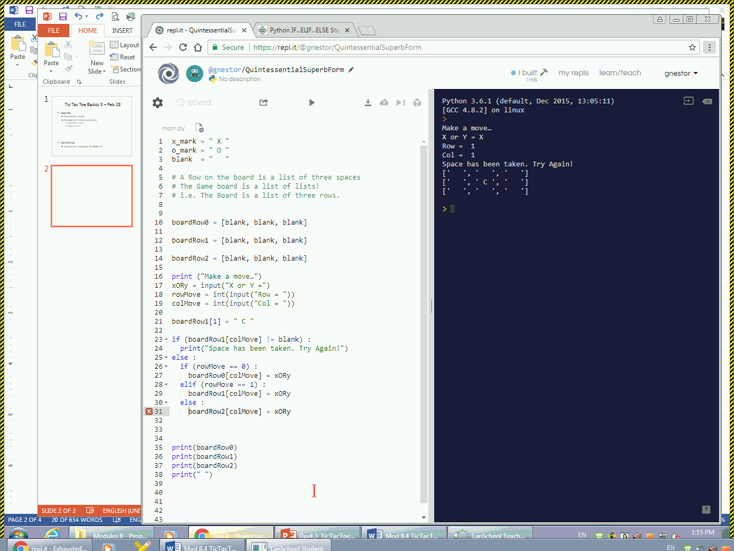

2)

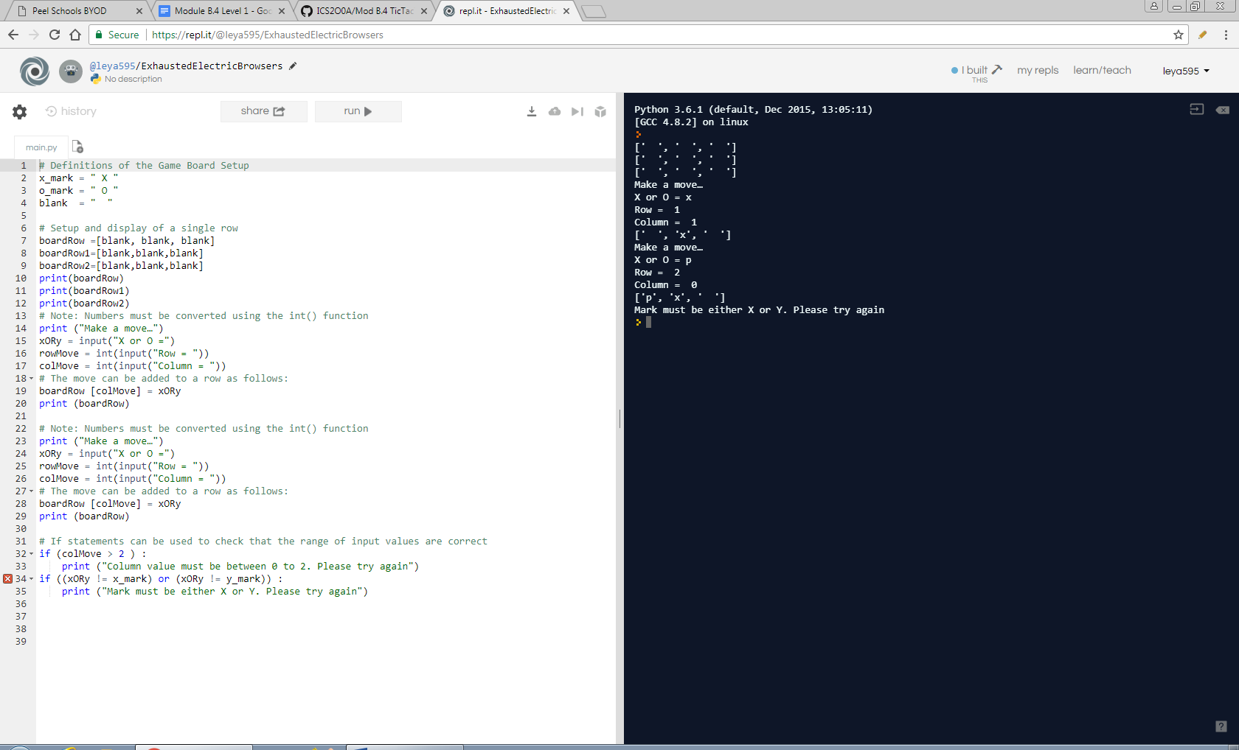

Screen Shot

1. When inputting other letter than x and y, or input a column that is greater than 2, it would be invalid and won’t work.

Level 4

Final Tic tac toe code:

# Definitions of the Game Board Setup

x_mark = " X "

o_mark = " O "

blank = " "

boardRow=[blank,blank,blank]

boardRow1=[blank,blank,blank]

boardRow2=[blank,blank,blank]

print(boardRow)

print(boardRow1)

print(boardRow2)

# Note: Numbers must be converted using the int() function

print ("Make a move…")

xORy = input("X or O =")

rowMove = int(input("Row = "))

colMove = int(input("Column = "))

# The move can be added to a row as follows:

boardRow [colMove] = xORy

print (boardRow)

if rowMove == int(0):

print (xORy) (boardRow)

elif rowMove == int(1):

print xORy (boardRow1)

else rowMove == int(2):

print (xORy) (boardRow2)

# Note: Numbers must be converted using the int() function

print ("Make a move…")

xORy = input("X or O =")

rowMove = int(input("Row = "))

colMove = int(input("Column = "))

# The move can be added to a row as follows:

boardRow [colMove] = xORy

print (boardRow)

x_mark = " X "

o_mark = " O "

blank = " "

# Setup and display of a single row

boardRow =[blank, blank, blank]

boardRow1=[blank,blank,blank]

boardRow2=[blank,blank,blank]

print(boardRow)

print(boardRow1)

print(boardRow2)

# Note: Numbers must be converted using the int() function

print ("Make a move…")

xORy = input("X or O =")

rowMove = int(input("Row = "))

colMove = int(input("Column = "))

# The move can be added to a row as follows:

boardRow [colMove] = xORy

print (boardRow)